Experiment 1
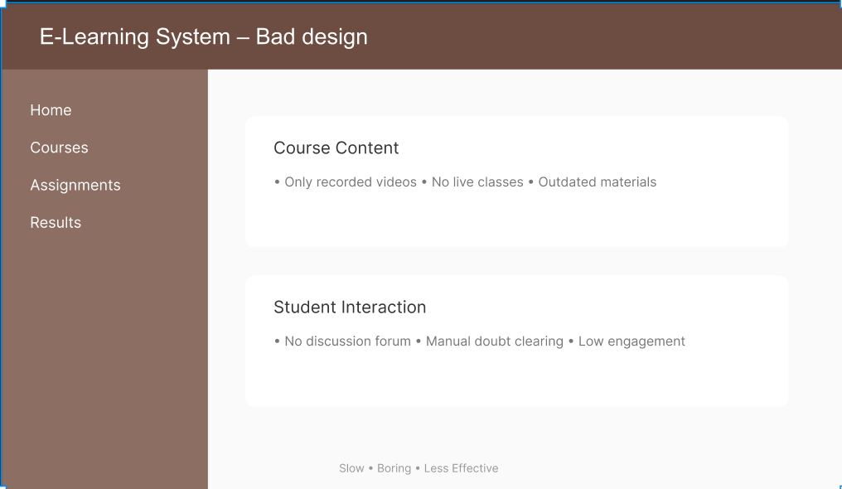

E-Learning System – Bad design
Home
Courses
Course Content
Assignments
• Only recorded videos • No live classes • Outdated materials
Results
Student Interaction
• No discussion forum • Manual doubt clearing • Low engagement
Slow • Boring • Less Effective
OLD UI DESIGN (BAD DESIGN)
Features & Drawbacks Identified

1. Flat & Dull UI
- The profile screen appears very simple and lacks visual appeal.
- No header image or background graphic is used.
- The plain background makes the interface look outdated and unengaging.
- The design does not attract users or encourage interaction.

2. Poor Profile Image Placement
- The item/profile image (Potato) is very small in size.
- It is placed inside a simple rectangular container.
- The image does not get enough visual importance.
- The placement looks old-fashioned and less professional.

3. Low Contrast & Readability Issues
- Light purple background with dark text creates low contrast.
- Text readability is reduced due to poor colour selection.
- Font sizes are inconsistent across headings and labels.
- Important information does not stand out clearly.

4. Poor Visual Hierarchy
- The item name (“Potato”) and recipe titles are not visually distinguished.
- Headings and sub-content use similar font size and colour.
- No clear emphasis on important sections.
- Users may find it difficult to scan information quickly.

5. Unstructured Layout
- Recipes are displayed in a vertical single-column layout.
- No clear separation between different sections.
- Content looks cluttered and poorly organised.
- Navigation is not intuitive.

6. Single Column Recipe Display
- All recipes are stacked one below the other.
- The layout feels long and repetitive.
- Screen space is not efficiently utilised.
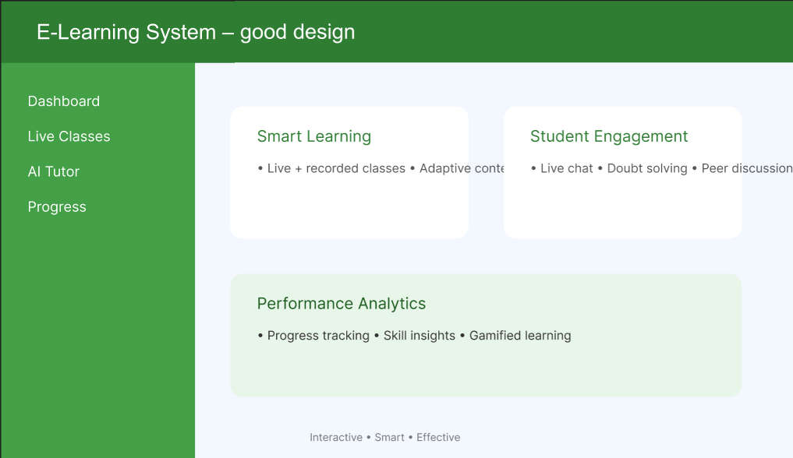
MODIFIED UI DESIGN (GOOD DESIGN)
Features & Enhancements
  - Header Background Section
- A coloured header section is added at the top.
- The header improves visual appeal and branding.
- Makes the profile screen look modern and attractive.
  - Profile Image Integration
- The potato image is displayed prominently in the centre.
- Circular image style gives a modern UI look.
- Image overlaps with the header section, improving aesthetics.
- The image size is increased for better visibility.

3. Improved Layout & Typography
- Proper spacing is used between elements.
- Text alignment is clean and symmetrical.
- Item name (“Potato”) is clearly highlighted.
- Fonts are consistent and readable.

4. Colour & Contrast Improvement
- Light background with dark text improves readability.
- Accent colours are used for buttons and highlights.
- Important information stands out clearly.
- Overall contrast is visually balanced.

  - Profile Statistics Display
- Posts count and Followers count are clearly displayed.
- Statistics are placed in a single row for better clarity.
- Makes information easy to understand at a glance.
- Improves user engagement.

  - Call-to-Action Button (Follow)
- A prominent “Follow” button is added.
- Button uses contrasting colour for visibility.
- Encourages user interaction.
- Button placement is easily accessible.

  - Structured Recipe Section
- Recipes are displayed in a grid layout.
- Images have uniform size and spacing.
- Layout looks clean and organised.
- Better use of screen space compared to single-column layout.
  - Improved Navigation Indicator
- A scroll-down indicator is provided.
- Helps users understand that more content is available.
- Enhances usability and user experience.

